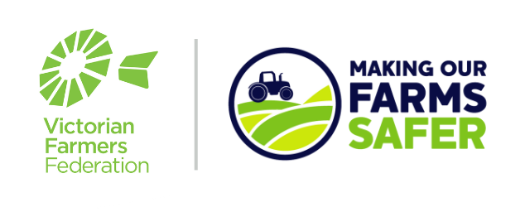

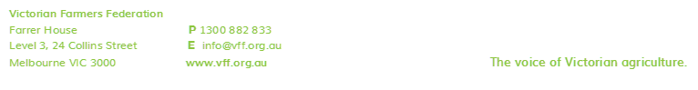
Templates for Farmers:
Inductions
From Page 2 onwards, this sample template can be used to create your own farm safety induction template. Following these instructions will mean that your company is one step closer to becoming compliant with your OH&S responsibilities.
As all farms are different, including different commodity types, it is important that you review this template and adjust it to ensure that it meets the needs of your farming business.
It is important to note that an induction is necessary from the point of meeting your legal duty to provide adequate information, instruction and training for new employees. Once you have provided an induction you still need to ensure that you to meet your duty to provide ongoing information, training, instruction and supervision, as is necessary, to ensure that your employees can work safely.

Instructions for Use:
- Open a new Word document with your company letterhead on it.
- Copy all text from Page 2 onwards, and paste it into your letterhead.
- Personalise the highlighted fields, to reflect your farm’s situation.
- Add specific hazards that are relevant to your farm that you want new employees to be made aware of, to this template.
- Fill in the table at the bottom with the version number, date, your name and a digital signature (or you can print the document off, sign it and scan it back in for your records).
- Add the policy name to the footer, as on this document.

What to do next:
- Present this policy document to your employees at a toolbox meeting, and ask them “what do you think we should take a new employee through from a safety point of view?” A record of who is in attendance at the toolbox meeting should be kept.
- Take on and address any feedback or concerns that your employees may have. Adjust as necessary.
- Have the template stored in an accessible place, for future reference and updating.

- Any future updates should be Saved As a new file, and the new version number and date written into the table at the bottom, for review by everyone, and signed again by the author.

Important note – The primary focus of this resource is to cover safety issues on your farm. This template does not include employment relations matters that you would also take an employee through such as Tax File numbers, banking details, superannuation, emergency contacts, employment contracts, awards and pay details.
EMPLOYER’S NAME
NOTE: The safety of people on this farm takes precedence over all other considerations
Draft SAFETY INDUCTION CHECKLIST (Amend as necessary)
Key Documentation
Employee Information | Covered?
Health, Safety and Welfare Policy
Work clothing requirements
Allergies – If employee has allergies, do they have the medication that they need to carry with them ie. EpiPen?
Provide contact details of farm management and check contact details of employee
Personal hygiene at work to prevent illness
Tetanus, Q Fever Awareness/Vaccine?
Copy of licenses and other tickets to be viewed by employer and notes kept. If license is lost employer needs to be notified immediately
Employee not to bring children to farm
Employer Policies
Bullying Policy
Drug and Alcohol Policy
Sexual Harassment Policy
Issue Resolution Process
Personal Protective Equipment Policy
UV Policy
Working Alone Policy
Visitors/Contractors on the Farm Policy
Return to Work Policy
Mobile Phone/Electronic Devices Use Policy
First Aid & Emergency
Emergency contacts
Recording of emergencies, accidents and incidents
Trained first aider/s
First aid kits
Fire-fighting equipment
Emergency assembly point/s
Evacuation/Code Red days
Emergency+ App
Training and Instruction
Employees will be trained on new machinery/implements and tasks. Training may be formal or informal and records will be kept of training received.
Once trained, employees will be supervised until assessed as competent.
Employees are not to use any farm machinery unless requested.
Safety Information
Safety information and advice will be provided during induction, at team meetings and often prior to activities. All employees are to follow instruction provided.
Employees are encouraged to contribute to the review of safety policies and safe systems of work.
Amenities
Toilets are …………
Drinking water is available ……….
Hand washing facilities are available ………
Employee safety requirements under Health & Safety Legislation
Employees are required to:
- take care for his or her own health and safety;
- care for the health and safety of everyone else on the farm;
- co-operate with the health and safety policies, safe work procedures, safety rules and other safety requirements that are in place on the farm; and
- do not intentionally or recklessly interfere with or misuse anything provided on the farm in the interests of health, safety or welfare.

General Safety Rules
- Report all safety problems immediately.
- Everyone is to be treated with respect.
- Poor behaviour (bullying, fighting, theft, racism, skylarking etc.) are grounds for sending workers home and may lead to job loss.
- Only persons assessed as competent or under supervision can operate farm machinery.
- Seat belts must be worn when fitted to any farm vehicle.
- Helmets must be worn with quad bikes, side-by-side vehicles, two wheelers and horses.
- Speed limit of 30 kms applies to all on farm roads and tracks. Reduce speed when weather conditions warrant it, or when leaving tracks.
- No one is to ride on any farm vehicle unless they have a seat. No passengers on quad bikes. No one is to ride on the back of utes, or trailers, or in fruit bins.
- When driving farm vehicles on the public road, all road rules must be followed.
- Chemicals and vet medicines to be handled by those with a current Chem Users certificate and who are wearing the correct PPE. Poisons to be handled by those who have an ACUP. Other workers only under strict supervision of a competent person.
- All silo ladder guards to be put in place when ladder not in use. Do not climb or enter silos, chaser bins or other tanks, pits etc.
- The following areas have been identified as No Go Zones on the farm:
1. Dams, creeks, culverts
2. Etc.
- Provide advice of where overhead powerlines are on the farm. (Could provide a map of the farm with this and No Go Zones and evacuation area, first aid kits etc.)

THE SAFETY OF PEOPLE ON THIS FARM TAKES PRECEDENCE OVER ALL OTHER CONSIDERATIONS

Signed: ____________________________ Date: ___ / ___ / ___
Employee/worker

Name: _____________________________
Print

Signed: ____________________________ Date: ___ / ___ / ___
Owner / Manager

Name: _____________________________
Print

