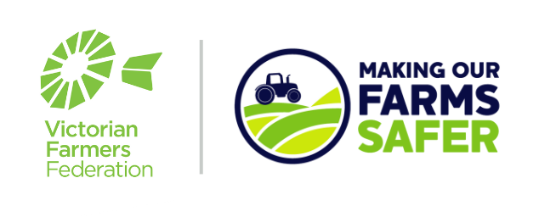

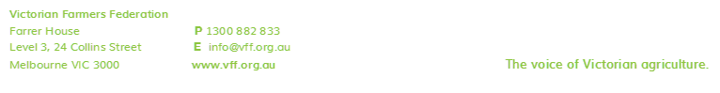
Templates for Farmers:
Toolbox Meeting Minutes

From Page 2 onwards, this document provides all the text you need, to keep appropriate records of your toolbox meetings. Following these instructions will mean that your company is one step closer to becoming compliant with your OH&S responsibilities.
It is important to note that these records alone are not enough to discharge your employer duties.

Instructions for Use:

- Open a new Word document with your company letterhead on it.
- Copy all text from Page 2 onwards, and paste it onto your letterhead.
- Personalise where highlighted, to reflect your company.

What to do next:

- Use this template to keep accurate records of your toolbox meetings.
- Have toolbox meetings as often as needed, but it is recommended that OHS should be on the agenda at least once per month.
- Ensure you write down all attendees/participants, as this helps with showing that you have “consulted with your employees about safety matters that affect their health”.
- Refer to your 6 Month Safety Action Plan (see ‘Sample Safety Action Plan’ Template on our website), to guide you through filling in the safety component of your meeting prior to the meeting.
- Add anything else discussed on the day.
- Take on and address any feedback or concerns that your employees may have. Adjust as necessary.
- Distribute and store copies of the completed toolbox meeting record as required, but in particular, keep a copy in your filing system.

(Your company’s letterhead)
RECORD OF OH&S TOOLBOX MEETING

Farm Location: | Meeting date:
Work group: | Distribution  - Site Safety Plan File  - Workers Notice Board
Meeting conducted by:
Attendance - all participants to be listed
Main subject of meeting:

Main issues covered:

Agreed actions:

Notes:

