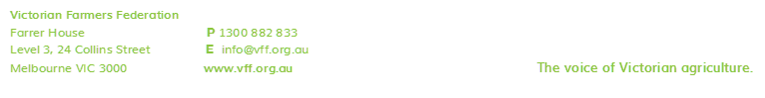Templates for Farmers:
Hazardous Substances and Dangerous Goods Register

The sample template on the next page can be used to create your own Hazardous Substances and Dangerous Goods Register for your farming business.
From Page 2 onwards, this document provides all the text you need, to maintain a register of Hazardous Substances and Dangerous Goods on your farm and to record important information such as the location. Following these instructions will mean that your company is one step closer to becoming compliant with your OH&S responsibilities.
It is important to note that these records alone are not enough to discharge your employer duties.

Instructions for Use:
- Open a new Word document with your company letterhead on it.
- Copy all text from Page 2 onwards, and paste it into your letterhead.
- Personalise the fields, to reflect your farm’s situation.
- Run through the checklist and fill in the required details.
- Store this document appropriately, and review/update as required.

Sample Hazardous Substances Register

An employer should complete each box and refer to information contained in relevant Material Safety Data Sheet

Company: Name of person compiling register:

Site/Work area: Date: Date for review of register:

Product Name | Location or process where product is used | Is product Hazardous?  This info will appear on MSDS | Is the product a Dangerous Good?  This info will appear on MSDS |  | Is the MSDS current  (not older than 5 years, refer to issue date on MSDS) |  | Risk Assessment |  |  |  | Actions/Comments
 |  | Yes/No | Yes/No | Class | Yes/No | Date | Haz Sub |  | Dangerous Good
 |  |  |  |  |  |  | Y/N | Date | Y/N | Date

